16 May 2019:

A Raspberry Pi (RPi) was used to continuously generate binary ON/OFF voltage signals which was then used to drive an IR LED while the voltage spikes were recorded on the USG 416H running at 250 kHz sampling rate. Audio files were saved in 1 minute clips over the course of the recording night. The IR LED signal was digitised by the DVR system at 22 Hz. The video files were saved as 1 hour clips over the night.

The ON/OFF signal :

The continuous ON/OFF signal was generated with the following pseudo code:

range_of_durations = [0.08,0.0801, 0.0802….0.5] # values between 0.08 and 0.5 seconds in steps of 0.1 milliseconds

while True:

1. Turn LED ON
2. choose random ON duration from range_of_duration
3. keep LED ON from random ON duration
4. TURN LED OFF
5. choose random OFF duration from range_of_duration
6. keep LED off for random OFF duration

Things to consider :

The LED signal :

The ON/OFF signal can be recovered looking at the brightness of the LED in a narrow region of interest in the video frames – this is reliable. However, because the DVR actually output files with a frame rate of 22 Hz, there will be some aliasing occuring. The ON/OFF signal has frequency components between 0.5-12.5 Hz, while the video file at 22 Hz has a Nyquist frequency at 11 Hz.

There may also be delays in the time taken to switch on the LED to full brightness – though given it's a small LED - this should be less than 26 microseconds ([source](https://learn.sparkfun.com/tutorials/ir-communication/all)).

The audio signal:

The USG 416H cannot record constant voltages and so a capacitor was used to generate 'ON' and 'OFF' spikes. A period where the LED was on can be figured out by an ON spike and an OFF spike occuring one after the other.

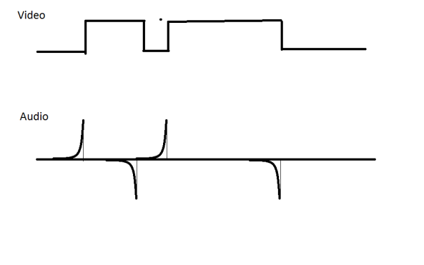

Figure 1 The video and audio signals as captured by the camera and USG 416H

August 2020: Notes made with hindsight

* The lowest ON/OFF duration (0.08 s) was too low – and should have been a bit longer. Even if the cameras had indeed run at 25 Hz, 80ms is right at the border of the Nyquist frequency. In a future run, I would have made the ON/OFF duration range between 0.1- 1.0 seconds.